Eurobrevets
B2K.NET Data Export
Documentation
Jean-Sébastien Maya Bravo
11/05/2020

Table of Contents
General description : 3
Installation steps : 3
Requirement 3
Extract archive 3
Modify fields 3
Import scheduled task 3
Exported files 3
Differences between B2K « Foxpro » and B2K « .NET » 4
Employees table, formerly CLI.DBF 4
Dotations 4
Functions 4
Access authorization to different conveyors 4
Models, Sizes, ModelSize, formerly MOD.DBF 4
Models : 4
GarmentSizes : 4
ModelsSizes : 4
Employees table: exported as CLI.csv 5
Fields description : 5
Sample snapshot : 8
Dotations table: exported as DOT.csv 10
Fields description : 10
Sample snapshot : 11
Categories table: exported as CAT.csv 12
Fields description : 12
Sample snapshot : 13
Functions table: exported as FUN.csv 14
Fields description : 14
Sample snapshot: 15
Models table: exported as MDL.csv 16
Fields description : 16
Sample snapshot: 17
GarmentSizes table: exported as GRS.csv 19
Fields description : 19
Sample snapshot: 20
ModelsSizes table: exported as MOD.csv 21
Fields description : 21
Sample snapshot: 23
Garments table: exported as ART.csv 26
Fields description : 26
Sample snapshot: 27
Movements table: exported as MOV.csv & STOMOV.csv 31
Fields description : 31
Sample snapshot: 32
Storages table: exported as MAG.csv 34
Fields description : 34
Sample snapshot: 34
StoragesPoints table: exported as STP.csv 35
Fields description : 35
Sample snapshot: 35
EmployeesGates table: exported as CLIMAG.csv 36
Fields description : 36
Sample snapshot: 36
Slots table: exported as MOC.csv 38
Fields description : 38
Sample snapshot: 39

General description:
This module consists of several Powershell scripts triggered by a windows scheduled task, which will perform requests on the SQL B2K.NET database and save the result to .csv files
The exported .csv files are not a raw export of the sql tables, where possible the fields are modified, renamed or joined from other tables to look as close as possible as foxpro’s DBF. Some tables and technical fields not relevant for business analysis are omitted.

Installation steps:

Requirement
Windows system with Powershell

Extract archive
Extract archive ExportCLF.7z to ‘C:\Metalpro.net\B2K.NET\Scripts’ or any other place where B2K.NET is installed. If the path is different, search for ‘C:\METALPRO.NET\B2K.NET\Scripts’ in ExportCLF directory and replace with the actual path.

Modify fields
Edit ExportB2KNET4CLF.xml and go to the field <Arguments> and replace :
“JS-EB” with the SQL Server instance name
“B2KNetDB” with the Database name (Not needed unless the default database name was renamed)
“sa” with the SQL Username (Not needed unless the default sql username was modified)
“SoloIo” SQL password (Not needed unless the default Metalprogetti password was modified)
<Arguments>-ExecutionPolicy Unrestricted c:\METALPRO.NET\B2K.NET\Scripts\ExportCLF\runAll.ps1 JS-EB B2KNetDB sa SoloIo 2&gt; C:\METALPRO.NET\B2K.NET\Scripts\exportCLF\error.txt</Arguments>

Import scheduled task
Open windows scheduled task and select “import task” and browse to select ExportB2KNET4CLF.xml
Eventually modify the trigger to select another time of export.

Exported files
If error occurs during export, they will be notified in C:\METALPRO.NET\B2K.NET\Scripts\exportCLF\error.txt
The exported files will be exported to C:\METALPRO.NET\B2K.NET\Scripts\exportCLF\Export\

Differences between B2K « Foxpro » and B2K « .NET »

Employees table, formerly CLI.DBF

Dotations
One of the most breaking change between B2K Foxpro and B2K.NET are the way dotations are handled.
In B2K Foxpro, an Employee could have 1 to 8 banalized dotations and 1 to 8 customized dotations.
In B2K.NET there is no more limit to the number of different dotations an employee can have. This is the cause of one of the biggest differences: the dotations are not store in the « CLI » table anymore, but are in a separate table.

Functions
The employees functions now have their own table, and are not anymore hard written for each employee.

Access authorization to different conveyors
The information of which conveyor an employee can use is now defined more accurately and with no limitation in a separate table, exported here as “CLIMAG.csv”
One (and one only) of the storage an employee can use must be set as his primary. The system will calculate needs for this user on this storage only.

Models, Sizes, ModelSize, formerly MOD.DBF

In B2K.NET, there are 3 different tables to store garments models :

Models :
Contains the informations for different models, regardless of their sizes.

GarmentSizes :
Contains the informations about possible sizes, regardless of the model.

ModelsSizes :
Link any possible sizes for a given model. This is the tables that dotations and garments will refer to.

Employees table: exported as CLI.csv

Fields description :
File name (B2K.net) | Field name (B2K.net) | Field explanation / description (B2K.net) | File name (Foxpro) | Field name (Foxpro)
CLI | EmployeeID | Unique Identifier for internal relationships in database | Not applicable | Not applicable
CLI | Cli | User's personnel number (NVARCHAR20) | CLI | Cli
CLI | Clinome | Concatenation of B2K.NET’s FirstName and LastName fields | CLI | Clinome
CLI | Clicat | Reference file CAT | CLI | Clicat
CLI | Clifunz | Reference file FUNC | CLI | Clifunz
CLI | Clitur | Reference file SHIFT | CLI | Clitur
CLI | CliDisableDate | Date when employee was disabled/deleted | Not applicable | Not applicable
CLI | Clicode |  | CLI | Clicode
CLI | Clivia |  | CLI | Clivia
CLI | Clicitta |  | CLI | Clicitta
CLI | Cliprov |  | CLI | Cliprov
CLI | Clicap |  | CLI | Clicap
CLI | Clitel |  | CLI | Clitel
CLI | CliMobile | Mobile phone | Not applicable | Not applicable
CLI | CliEmailAddress | Email address | Not applicable | Not applicable
CLI | CliCreationDate | Date of creation of this user in the system | Not applicable | Not applicable
CLI | Clisex | 0: Male  1: Female | CLI | Clisex
CLI | Clinatoil | dd-mm-yy hh:mm:ss | CLI | Clinatoil
CLI | Clinatoa |  | CLI | Clinatoa
CLI | Clidatai | dd-mm-yy hh:mm:ss | CLI | Clidatai
CLI | Clidataf | dd-mm-yy hh:mm:ss | CLI | Clidataf
CLI | Cliferiei | dd-mm-yy hh:mm:ss | CLI | Cliferiei
CLI | Cliferief | dd-mm-yy hh:mm:ss | CLI | Cliferief
Not applicable | Not applicable |  | CLI | Clitaglia
CLI | Clisizes | 0:No  1:Missing size  2:Always | CLI | Clisizes
CLI | Clipickup | 0:Standard  1:Deliver all  2:Deliver 1 of each | CLI | Clipickup
CLI | Clifasi | Not used : NULL value | CLI | Clifasi
CLI | Clilang | nl-NL, fr-FR, en-US, … | CLI | Clilang
CLISTO | Not applicable |  | CLI | Climags
CLISTO | Not applicable |  | CLI | Climaga
CLI | Climagall | This field exists but is not used. Conveyor usage defined in CLISTO file.  0:no  1:yes | CLI | Climagall
CLI | Clinote |  | CLI | Clinote
CLI | Clisendnote | Display clinote on delivery screen :  0: No  1: Always  2: Once | Not applicable | Not applicable
DOT | Not applicable |  | CLI | CLIMODP1
DOT | Not applicable |  | CLI | CLIMODP2
DOT | Not applicable |  | CLI | CLIMODP3
DOT | Not applicable |  | CLI | CLIMODP4
DOT | Not applicable |  | CLI | CLIMODP5
DOT | Not applicable |  | CLI | CLIMODP6
DOT | Not applicable |  | CLI | CLIMODP7
DOT | Not applicable |  | CLI | CLIMODP8
DOT | Not applicable |  | CLI | CLIMODL1
DOT | Not applicable |  | CLI | CLIMODL2
DOT | Not applicable |  | CLI | CLIMODL3
DOT | Not applicable |  | CLI | CLIMODL4
DOT | Not applicable |  | CLI | CLIMODL5
DOT | Not applicable |  | CLI | CLIMODL6
DOT | Not applicable |  | CLI | CLIMODL7
DOT | Not applicable |  | CLI | CLIMODL8
DOT | Not applicable |  | CLI | CLIMAXS1
DOT | Not applicable |  | CLI | CLIMAXS2
DOT | Not applicable |  | CLI | CLIMAXS3
DOT | Not applicable |  | CLI | CLIMAXS4
DOT | Not applicable |  | CLI | CLIMAXS5
DOT | Not applicable |  | CLI | CLIMAXS6
DOT | Not applicable |  | CLI | CLIMAXS7
DOT | Not applicable |  | CLI | CLIMAXS8
DOT | Not applicable |  | CLI | CLIDOTA1
DOT | Not applicable |  | CLI | CLIDOTA2
DOT | Not applicable |  | CLI | CLIDOTA3
DOT | Not applicable |  | CLI | CLIDOTA4
DOT | Not applicable |  | CLI | CLIDOTA5
DOT | Not applicable |  | CLI | CLIDOTA6
DOT | Not applicable |  | CLI | CLIDOTA7
DOT | Not applicable |  | CLI | CLIDOTA8
DOT | Not applicable |  | CLI | CLINUMS1
DOT | Not applicable |  | CLI | CLINUMS2
DOT | Not applicable |  | CLI | CLINUMS3
DOT | Not applicable |  | CLI | CLINUMS4
DOT | Not applicable |  | CLI | CLINUMS5
DOT | Not applicable |  | CLI | CLINUMS6
DOT | Not applicable |  | CLI | CLINUMS7
DOT | Not applicable |  | CLI | CLINUMS8
DOT | Not applicable |  | CLI | CLIDOTU1
DOT | Not applicable |  | CLI | CLIDOTU2
DOT | Not applicable |  | CLI | CLIDOTU3
DOT | Not applicable |  | CLI | CLIDOTU4
DOT | Not applicable |  | CLI | CLIDOTU5
DOT | Not applicable |  | CLI | CLIDOTU6
DOT | Not applicable |  | CLI | CLIDOTU7
DOT | Not applicable |  | CLI | CLIDOTU8
CLI | Clidatamov | dd-mm-yy hh:mm:ss | CLI | Clidatamov
CLI | Not applicable |  | CLI | Clitimeuso

Sample snapshot :
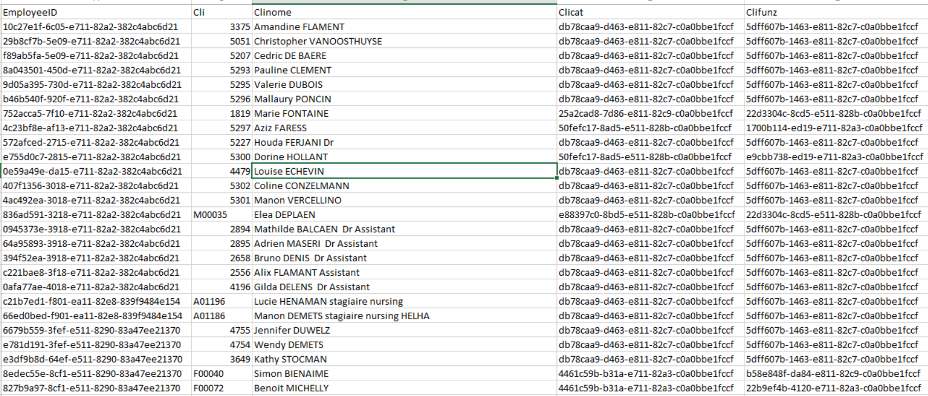

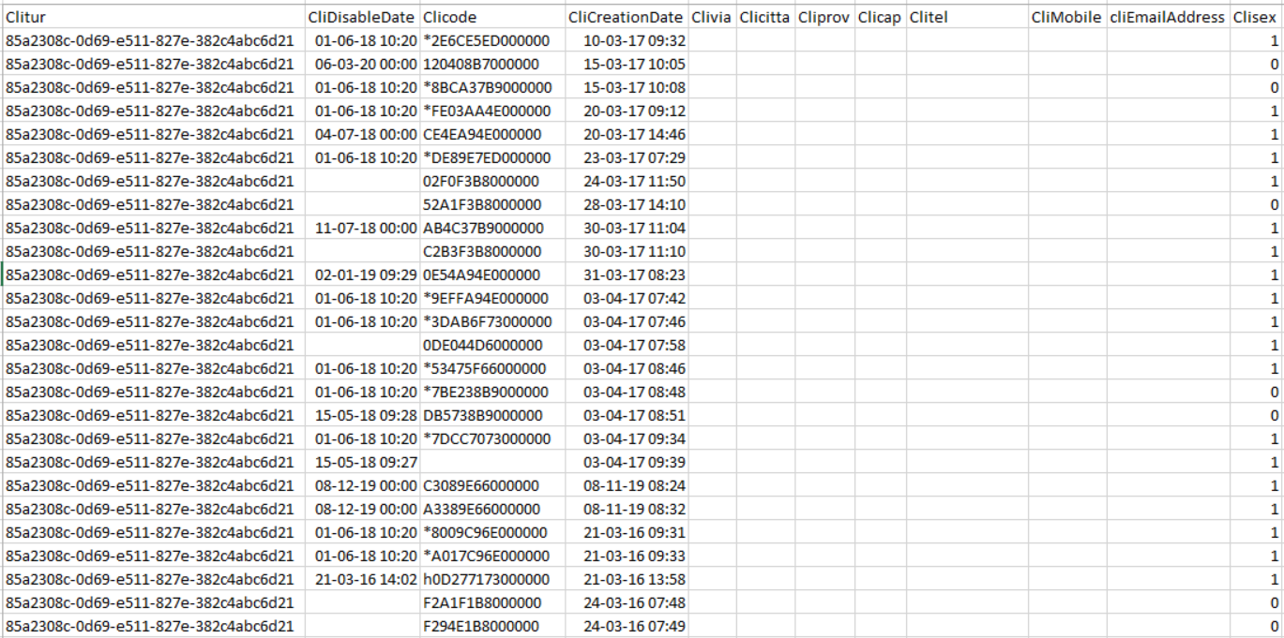
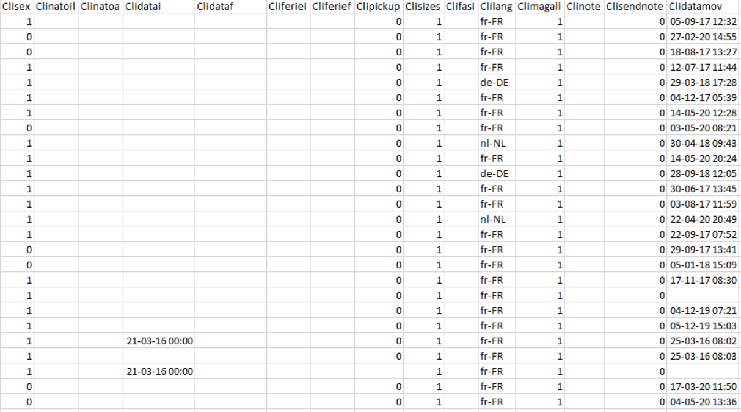

Dotations table: exported as DOT.csv

Fields description :
File name (B2K.net) | Field name (B2K.net) | Field explanation / description (B2K.net) | File name (Foxpro) | Field name (Foxpro)
DOT | DotationID | GUID for database internal use | Not Applicable | Not Applicable
DOT | EmployeeID | Reference to the employee’s GUID | Not Applicable | Not Applicable
DOT | ModelSizeID | Reference to the Model/Size’s GUID | Not Applicable | Not Applicable
DOT | MaxDailyDotation | Max count of garments the employee can have in its possession for this dotation | Not Applicable | Not Applicable
DOT | MaxWeeklyDotation | Max count of garments the employee can withdraw in one week for this dotation | Not Applicable | Not Applicable
DOT | UsedDailyDotation | Actual count of garments the employee have in its possession for this dotation | Not Applicable | Not Applicable
DOT | UsedWeeklyDotation | Actual count of garments the employee already withdrawn this week for this dotation | Not Applicable | Not Applicable
DOT | UseTypeEnum | Type of dotation | Not Applicable | Not Applicable
DOT | Reset | Reset dotation weekly. (NOT USED NOW) | Not Applicable | Not Applicable
DOT | DateToReset | Next date when reset weekly dotation. (NOT USED NOW) | Not Applicable | Not Applicable

Sample snapshot :
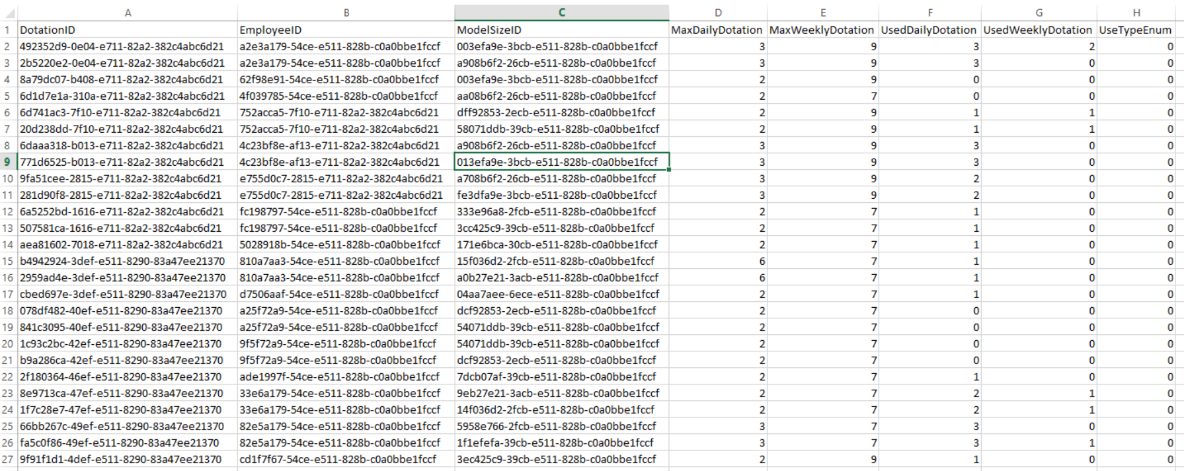

Categories table: exported as CAT.csv

Fields description :

File name (B2K.net) | Field name (B2K.net) | Field explanation / description (B2K.net) | File name (Foxpro) | Field name (Foxpro)
CAT | CategoryID | GUID for database internal use | Not Applicable | Not Applicable
CAT | Cat | Category code  This code is used for Import | CAT | Cat
CAT | Catdesc |  | CAT | Catdesc

Sample snapshot :
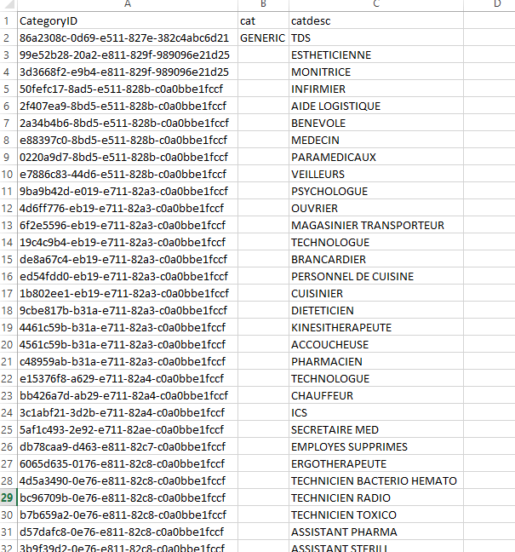

Functions table: exported as FUN.csv

Fields description :

File name (B2K.net) | Field name (B2K.net) | Field explanation / description (B2K.net) | File name (Foxpro) | Field name (Foxpro)
FUN | FunctionID | GUID for database internal use | Not Applicable | Not Applicable
FUN | Fun | Function’s code  This code is used for Import | CLI
FUN | Fundesc |  | CLI | Clifunz

Sample snapshot:
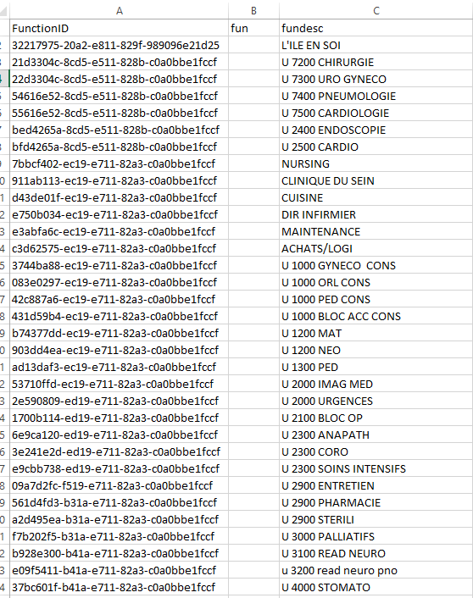

Models table: exported as MDL.csv

Fields description :

File name (B2K.net) | Field name (B2K.net) | Field explanation / description (B2K.net) | File name (Foxpro) | Field name (Foxpro)
MDL | ModelID | GUID for database internal use | Not Applicable | Not Applicable
MDL | Code | Model code (regardless of size)  This code is used for Import | MOD | Modtgrp
MDL | Description | Description in AppUser | MOD | Moddesc
MDL | ShortDescription | Description in AppGate | MOD | Moddesc2
MDL | OccupationSlots | If empty or 0 means 1 | MOD
MDL | PackageEnum | Model type :  0:Model  1:Kit  2:Bag  3:Accessory | Not Applicable | Not Applicable
MDL | AdjustedNeeds | Coefficient for needs calculation | Not Applicable | Not Applicable
MDL | FamilyID | Reference to the Family’s GUID | Not Applicable | Not Applicable
MDL | BuyerCode | Informative field | Not Applicable | Not Applicable
MDL | TranscodeID |  | MOD | Modie
MDL | fromDate |  | MOD | Moddadata
MDL | toDate |  | MOD | Modadata
MDL | ResetDotation | Not used | MOD | Modreset
MDL | TypeEnum | 0:Hanged  1:Folded  2:Both | MOD | Modtipo
MDL | MaxCompleteCycle | Max washing count before discarding garments | MOD | Modcicli

Sample snapshot:
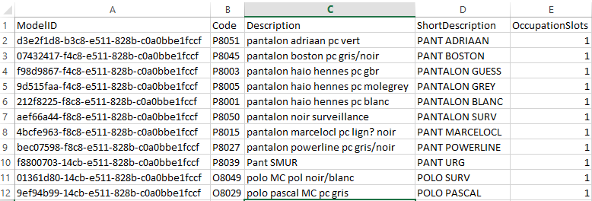
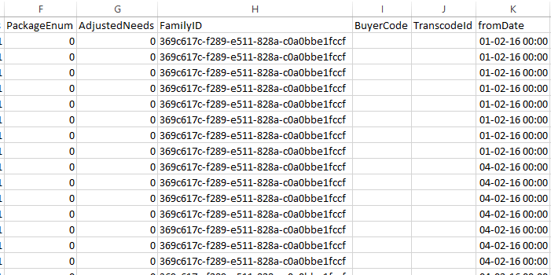
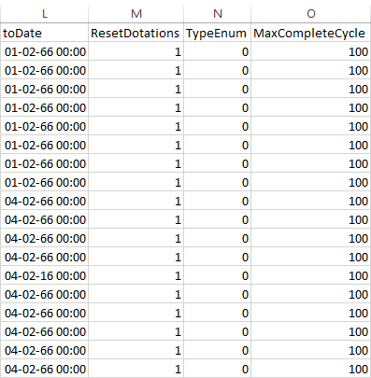

GarmentSizes table: exported as GRS.csv

Fields description :

File name (B2K.net) | Field name (B2K.net) | Field explanation / description (B2K.net) | File name (Foxpro) | Field name (Foxpro)
GRS | GarmentSizeID | GUID for database internal use | Not Applicable | Not Applicable
GRS | Code | Size code (for import) | MOD | Modtaglia
GRS | Description |  | Not Applicable | Not Applicable
GRS | SizeSetID | Reference to the SizeSet’s GUID | Not Applicable | Not Applicable
GRS | ShortDescription |  | Not Applicable | Not Applicable
GRS | OrderPosition | Integer to sort size for alternative sizes selection | Not Applicable | Not Applicable
GRS | TranscodeID |  | Not Applicable | Not Applicable

Sample snapshot:
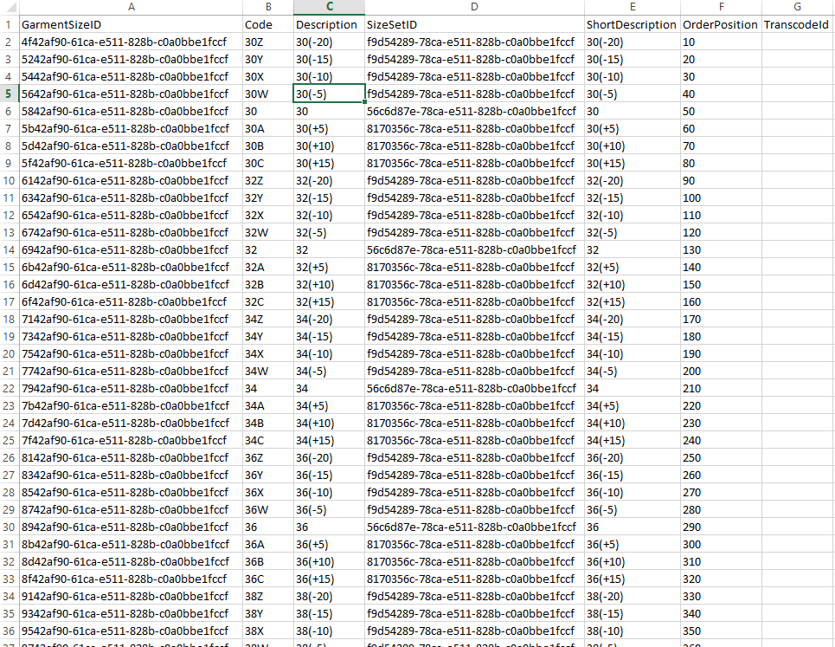

ModelsSizes table: exported as MOD.csv

Fields description :

File name (B2K.net) | Field name (B2K.net) | Field explanation / description (B2K.net) | File name (Foxpro) | Field name (Foxpro)
MOD | ModelSizeID | GUID for database internal use | Not Applicable | Not Applicable
MOD | ModelID | Reference to the Model’s GUID | Not Applicable | Not Applicable
MOD | GarmentSizeID | Reference to the GarmentSize’s GUID | Not Applicable | Not Applicable
MOD | Mod | Concatenation of model code and size code, like it was in Foxpro | MOD | Mod
MOD | Moddesc | (From MDL) | MOD | Moddesc
MOD | Moddesc2 | (From MDL) | MOD | Moddesc2
MOD | Modpris | (From MDL)  If empty or 0 means 1 | MOD | Modpris
MOD | Not Applicable |  | MOD | Modobbligo
MOD | Not Applicable |  | MOD | Modkitpos
MOD | Modtgrp | (From MDL) Model code | MOD | Modtgrp
MOD | Modtpos | (From GRS) Integer to sort size for alternative sizes selection | MOD | Modtpos
MOD | Modtaglia | (From GRS) Size code | MOD | Modtaglia
MOD | Not Applicable |  | MOD | Modclicat
MOD | Not Applicable |  | MOD | Modcodacq
MOD | Not Applicable |  | MOD | Modcosto
MOD | Not Applicable |  | MOD | Moddadata
MOD | Not Applicable |  | MOD | Modadata
MOD | Not Applicable |  | MOD | Modkit1
MOD | Not Applicable |  | MOD | Modkit2
MOD | Not Applicable |  | MOD | Modkit3
MOD | Not Applicable |  | MOD | Modkit4
MOD | Not Applicable |  | MOD | Modkit5
MOD | Not Applicable |  | MOD | Modkit6
MOD | Not Applicable |  | MOD | Modkit7
MOD | Not Applicable |  | MOD | Modkit8
MOD | Not Applicable |  | MOD | Modimage
MOD | Modie | (From MDL) | MOD | Modie
MOD | Not Applicable |  | MOD | Modid
MOD | Not Applicable |  | MOD | Modflag
MOD | Not Applicable |  | MOD | Modappeso
MOD | Not Applicable |  | MOD | Modpiega
MOD | Not Applicable |  | MOD | Modpre
MOD | Not Applicable |  | MOD | Modpost
MOD | Modcicli | (From MDL)  Max washing count before discarding garments | MOD | Modcicli
MOD | Modreset | (From MDL)  Field not used | MOD | Modreset
MOD | Not Applicable |  | MOD | Modbucaout
MOD | Modtipo | (From MDL)  0:Hanged  1:Folded  2:Both | MOD | Modtipo

Sample snapshot:
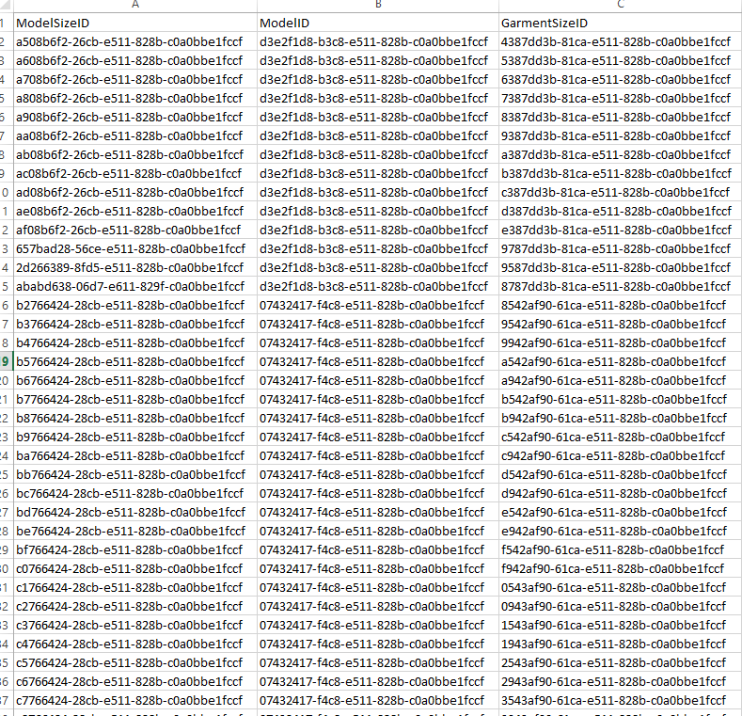
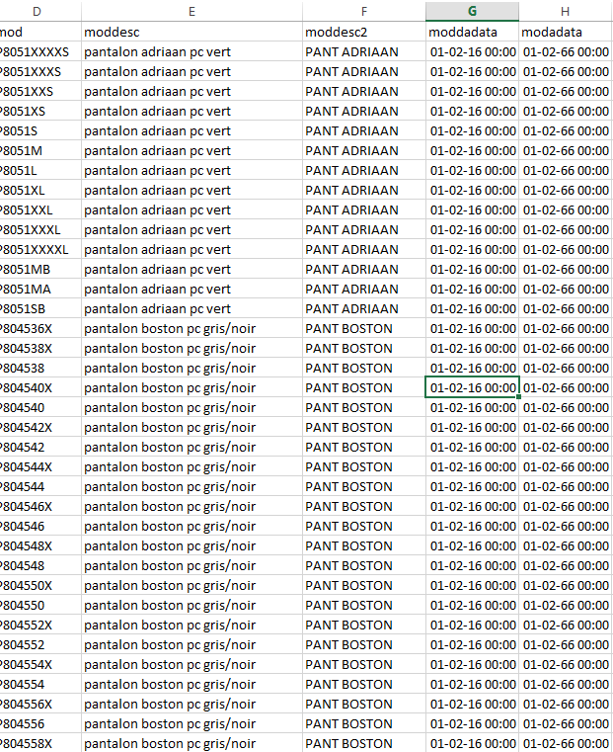
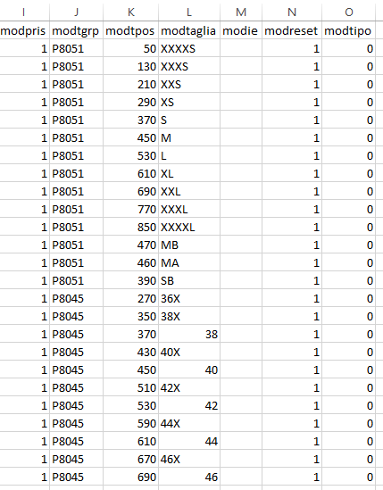

Garments table: exported as ART.csv

Fields description :

File name (B2K.net) | Field name (B2K.net) | Field explanation / description (B2K.net) | File name (Foxpro) | Field name (Foxpro)
ART | GarmentID | GUID for database internal use | Not Applicable | Not Applicable
ART | Art | Chipcode | ART | Art
ART | Artdesc |  | ART | Artdesc
ART | Artcli | Reference to the Employee’s GUID if status is delivered or garment is private | ART | Artcli
Art | ModelSizeID | Reference to the ModelSize’s GUID | Not Applicable | Not Applicable
ART | Artmod | (FROM MOD) | ART | Artmod
ART | Artpris | If empty or 0 means 1 | ART | Artpris
ART | Artstato | 0:New  1:Loaded  2:Delivered  3:Returned  4:Transfer  5:Unloaded as anomaly  7:Refused  8:Cancelled  9:Lended | ART | Artstato
ART | Artstatot |  | ART | Artstatot
ART | UseTypeEnum | 0:public garment  1:private garment | Not Applicable | Not Applicable
Not Applicable | Not Applicable |  | ART | Artstato2
Not Applicable | Not Applicable |  | ART | Artcliuso
Not Applicable | Not Applicable |  | ART | Artkit
Not Applicable | Not Applicable |  | ART | Artkitpos
Not Applicable | Not Applicable |  | ART | Artstato8
Not Applicable | Not Applicable |  | ART | Artstato9
ART | Artdata8 | Date of creation | ART | Artdata8
Not Applicable | Not Applicable |  | ART | Artdata9
Not Applicable | Not Applicable |  | ART | Artabsstat
ART | SlotID | Ref to the Slot’s (moc) GUID | Not Applicable | Not Applicable
ART | StorageID | Ref to the Storage’s (mag) GUID | Not Applicable | Not Applicable
ART | StorageGroupID | Reference to the StorageGroup’s GUID | Not Applicable | Not Applicable

Sample snapshot:
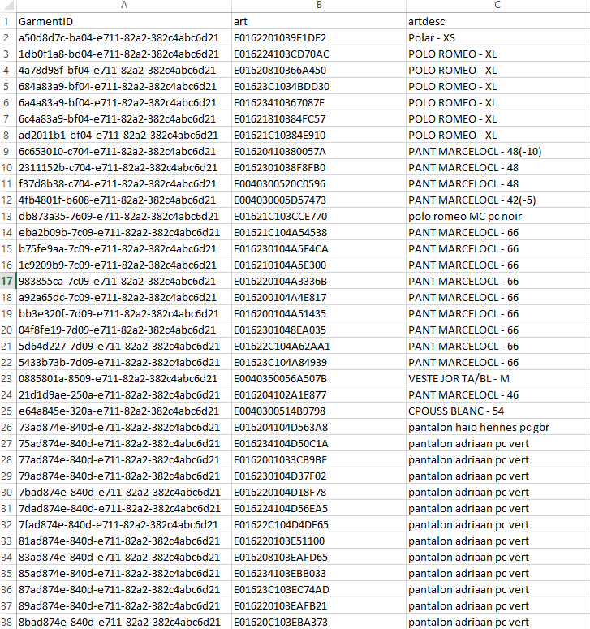
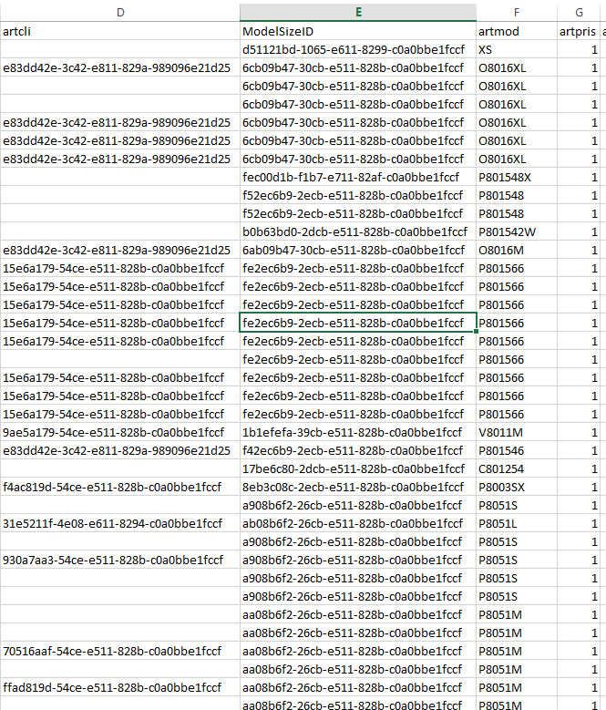
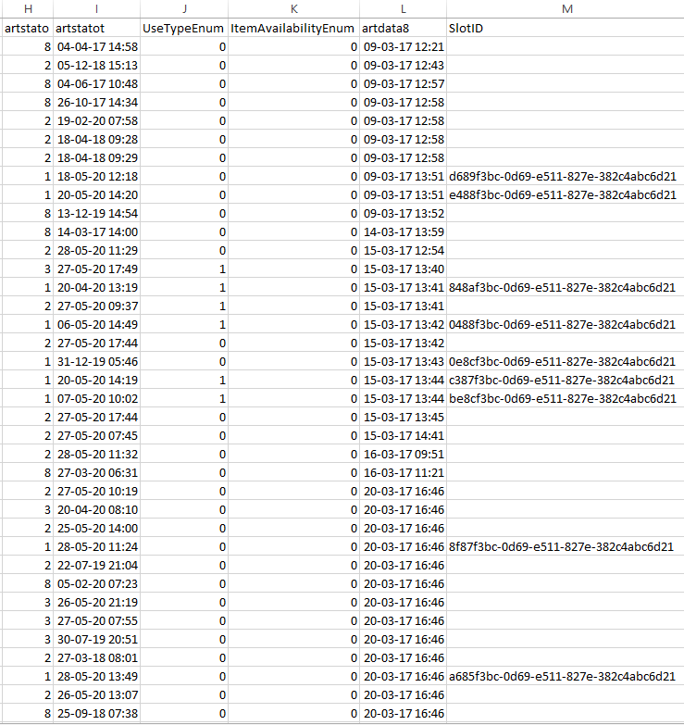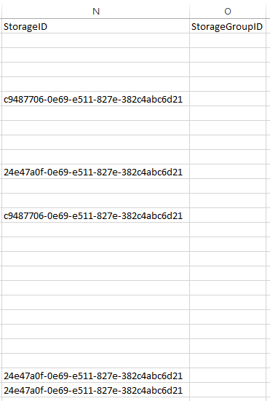

Movements table: exported as MOV.csv & STOMOV.csv

Fields description :

File name (B2K.net) | Field name (B2K.net) | Field explanation / description (B2K.net) | File name (Foxpro) | Field name (Foxpro)
MOV | MovementID | GUID for database internal use | Not Applicable | Not Applicable
MOV | Movdata |  | MOV | Movdata
MOV | Movora |  | MOV | Movora
MOV | Movop |  | MOV | Movop
MOV | Movflag |  | MOV | Movflag
MOV | UseTypeEnum | 0: Public  1: Private | Not Applicable | Not Applicable
MOV | Movcli | Reference to the Employee’s GUID | MOV | Movcli
MOV | ModelSizeID | Reference to the ModelSize’s GUID | Not Applicable | Not Applicable
MOV | Movmod | (FROM MOD) | MOV | Movmod
Not Applicable | Not Applicable |  | MOV | Movartcli
MOV | GarmentID | Reference to the Garment’s GUID | Not Applicable | Not Applicable
MOV | Movart |  | MOV | Movart
MOV | Movmag |  | MOV | Movmag
MOV | StoragePointID | Reference to the Garment’s GUID
MOV | StoragePoint | Storage Point code where movement occurred. Can be a gate but also transfer, anomaly arm, loading point | Not Applicable | Not Applicable
MOV | Movcas |  | MOV | Movcas
Not Applicable | Not Applicable |  | MOV | Movkit
MOV | Movtimei |  | MOV | Movtimei
MOV | Movtimee |  | MOV | Movtimee
MOV | Movprogre |  | MOV | Movprogre
Not Applicable | Not Applicable |  | MOV | Movbdesc
Not Applicable | Not Applicable |  | MOV | Movsigout

Sample snapshot:
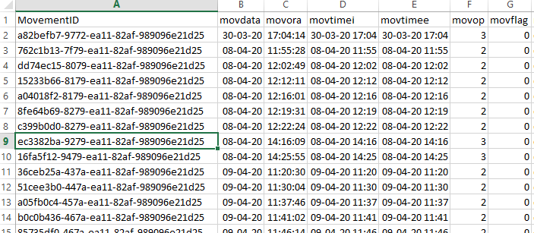
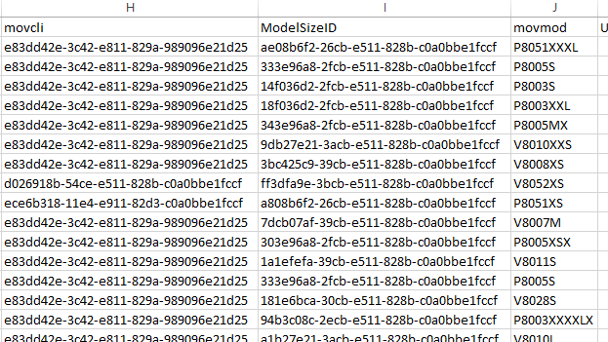
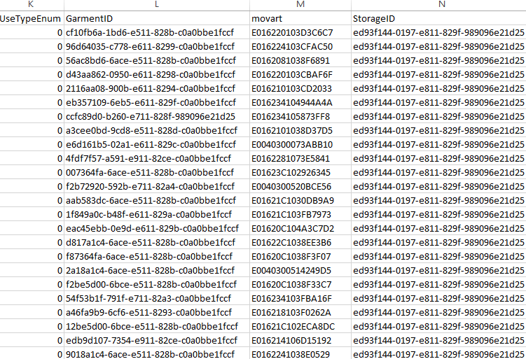
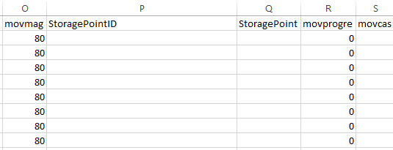

Storages table: exported as MAG.csv

Fields description :

File name (B2K.net) | Field name (B2K.net) | Field explanation / description (B2K.net) | File name (Foxpro) | Field name (Foxpro)
MAG | StorageID | GUID for database internal use | Not Applicable | Not Applicable
MAG | Mag | Conveyor code | MAG | Mag
MAG | Desc |  | MAG | Desc
MAG | Gps | PLC number | MAG | Gps
MAG | Gpstype | PLC technology | MAG | Gpstype
MAG | Lib1ogni | Keep 1 empty slot each … | MAG | Lib1ogni

Sample snapshot:
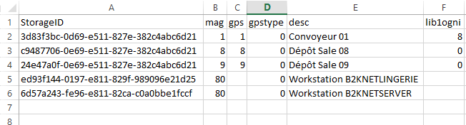

StoragesPoints table: exported as STP.csv

Fields description :

File name (B2K.net) | Field name (B2K.net) | Field explanation / description (B2K.net) | File name (Foxpro) | Field name (Foxpro)
STP | StoragePointID | GUID for database internal use | Not Applicable | Not Applicable
STP | StorageID | Reference to the Storage’s GUID | Not Applicable | Not Applicable
STP | StoragePointIdentification | Conveyor point’s code | PCS | Pcs
STP | StoragePointDescription |  | PCS | Desc

Sample snapshot:
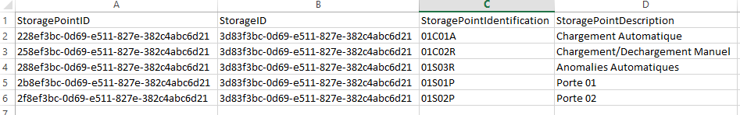

EmployeesGates table: exported as CLIMAG.csv

Fields description :

File name (B2K.net) | Field name (B2K.net) | Field explanation / description (B2K.net) | File name (Foxpro) | Field name (Foxpro)
CLIMAG | EmployeeGateID | GUID for database internal use | Not Applicable | Not Applicable
CLIMAG | EmployeeID | Reference to the Employee’s GUID
CLIMAG | Cli | (FROM CLI) | CLI | Cli
CLIMAG | Clinome | (FROM CLI) | CLI | Clinome
CLIMAG | StoragePointIdentification |  | Not Applicable | Not Applicable
CLIMAG | StoragePointDescription |  | Not Applicable | Not Applicable
CLIMAG | PrimaryEnum | 0: Not primary  1: Primary | Not Applicable | Not Applicable

Sample snapshot:

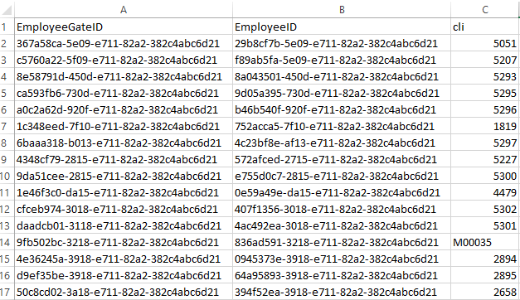
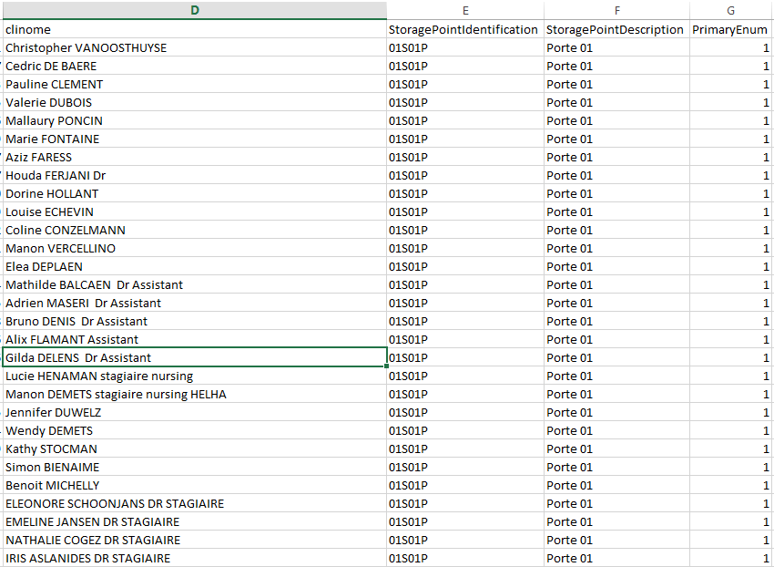

Slots table: exported as MOC.csv

Fields description :

File name (B2K.net) | Field name (B2K.net) | Field explanation / description (B2K.net) | File name (Foxpro) | Field name (Foxpro)
MOC | SlotID | GUID for database internal use | Not Applicable | Not Applicable
MOC | StorageID |  | Not Applicable | Not Applicable
MOC | Mocmag |  | MOC | Mocmag
MOC | Moccas |  | MOC | Moccas
MOC | Moctoc | 0: Free  1: Occupied  2: Reserved  3: Booked  4: Maintenance | MOC | Moctoc
MOC | SlotErrorEnum | 0 : No anomaly  1: Unread  15: Unregistered  17: ImportExport  20: Cancelled | Not Applicable | Not Applicable
MOC | Mocpris |  | MOC | Mocpris
MOC | Mocdata |  | MOC | Mocdata
Not Applicable | Not Applicable |  | MOC | Mocscad
Not Applicable | Not Applicable |  | MOC | Mocusato
MOC | EmployeeID |  | MOC | Moccli
MOC | Mocmod |  | MOC | Mocmod
Not Applicable | Not Applicable |  | MOC | Moctur
MOC | Mocart |  | MOC | Mocart
Not Applicable | Not Applicable |  | MOC | Mocprog
Not Applicable | Not Applicable |  | MOC | Mockit

Sample snapshot:
